Configure Eclipse IDE to connect to Bit bucket Repository

|  |  |  |  |
| --- | --- | --- | --- |
| Version | Author | Date | Remarks |
| 0.1 | Atul Gogte | 4th Nov 2016 | initial draft version |
| 1.0 | Atul Gogte | 11th Nov 2016 | Updated few sections |

Configure Eclipse IDE to connect to Bit bucket Repository

Step-1 Download/Install egit plugin into your eclipse

* Open Eclipse
* Click on Help menu
* Click Install New Software

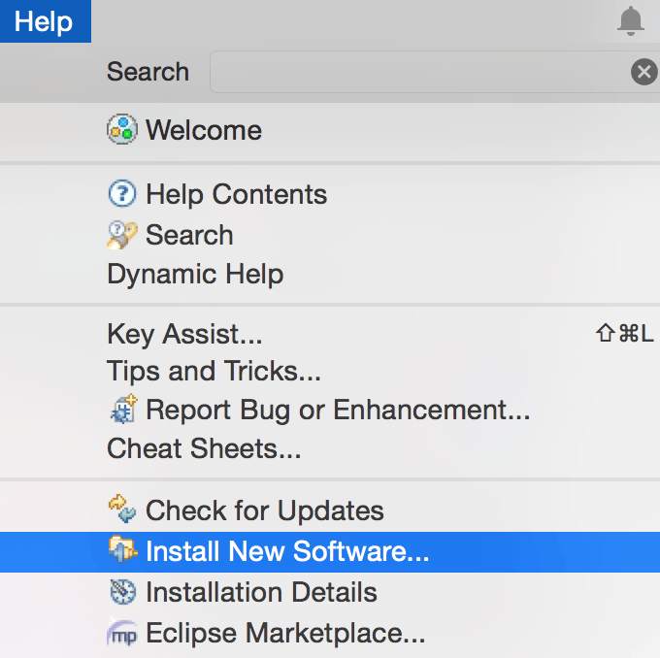

Enter URL: <http://download.eclipse.org/egit/updates>

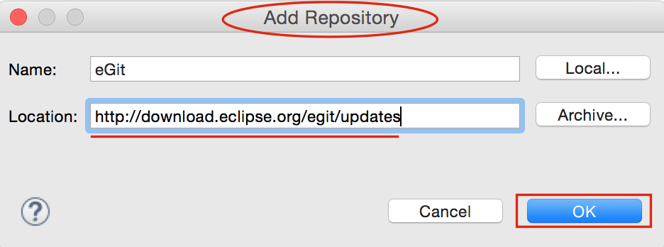

Select Eclipse Git Team Provider and JGit form option and click next and finish install.

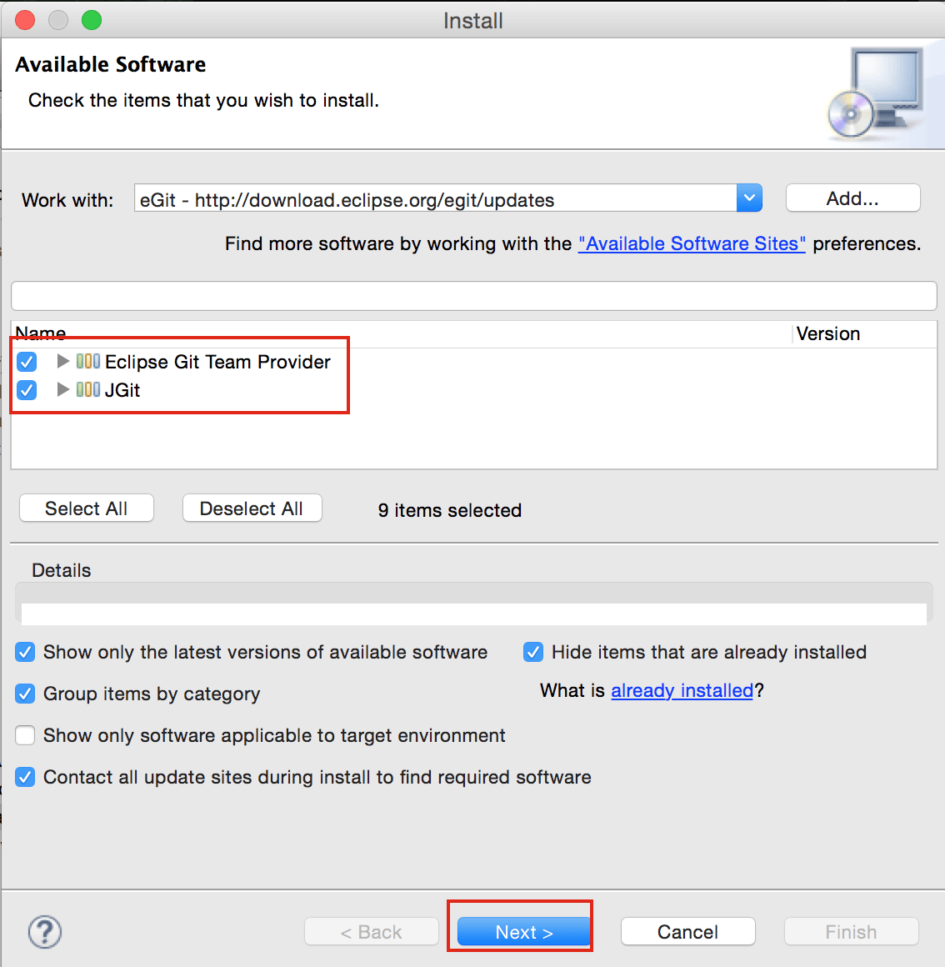

Step 2 – Cloning bit bucket repository into git perspective.

Now Open Perspective and choose Git from list.

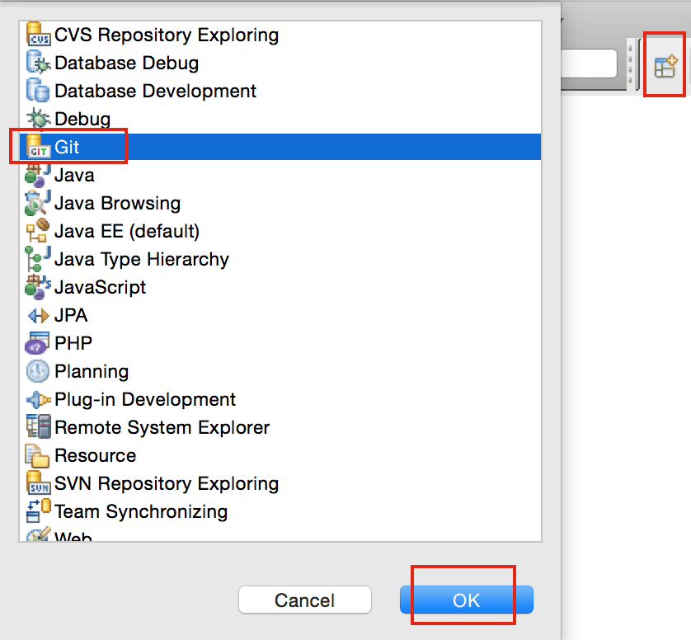

Click Clone Repository Button.

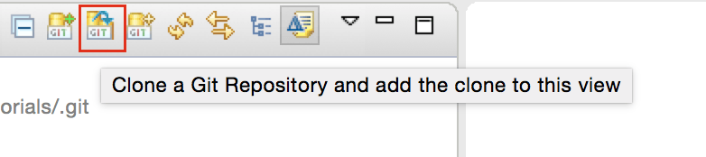

Enter your Bitbucket URL and User Information as mentioned in below diagram. Click Next and Finish. No need to change other configuration in next window.

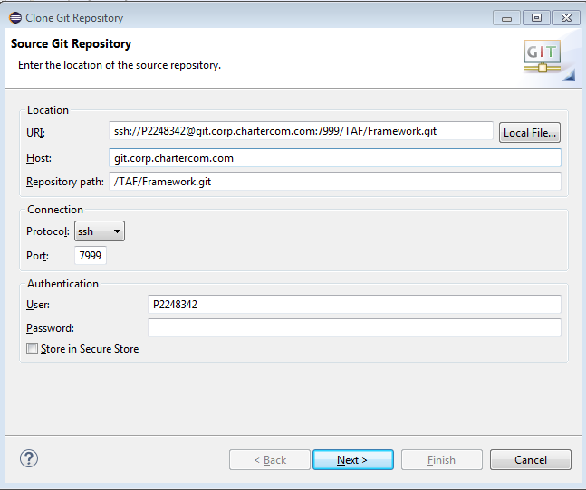

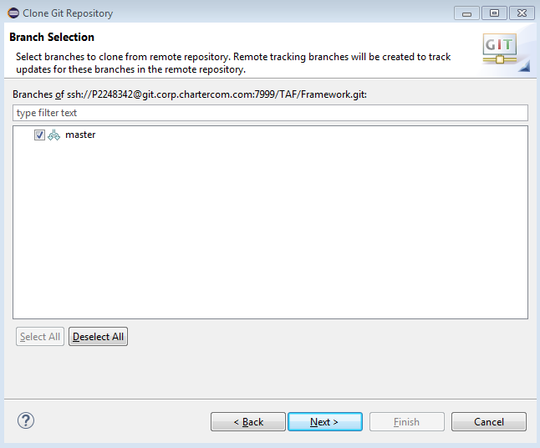

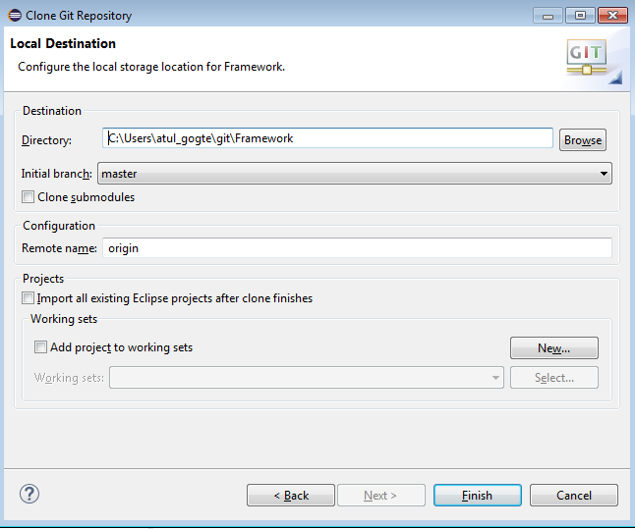

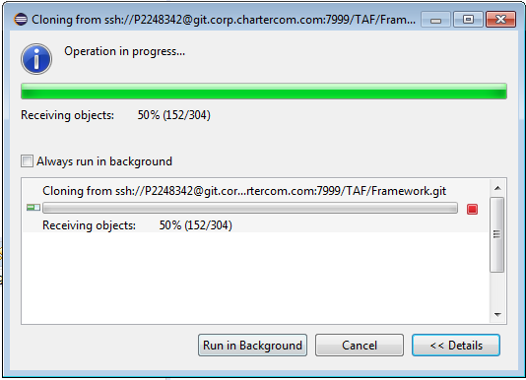

Now you will see the bit bucket repository inside your Eclipse

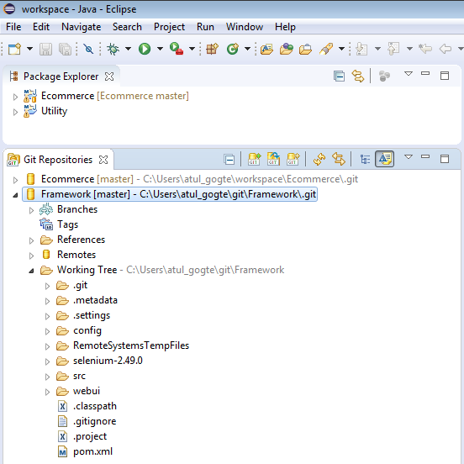

Step 3 – Import the cloned repository into project/package explorer

Now you may want to import the project so you can work on the source code.

1. Click
   1. ‘Windows’ >
   2. ‘Open Perspective’ >
   3. ‘Resource’
2. Click
   1. ‘File’ >
   2. ‘Import’ >
   3. ‘Git’ >
   4. ‘Projects from Git’ >
   5. ‘Existing local repository’ >
   6. ‘Select a Git Repository’ >
   7. ‘Import as General Project’ >
   8. ‘Next’ >
   9. ‘Finish’

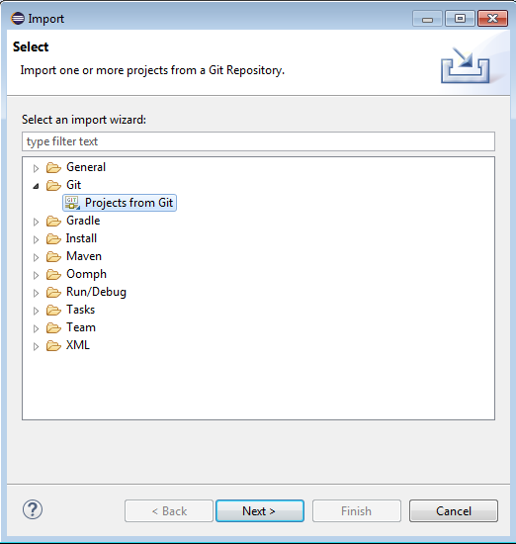

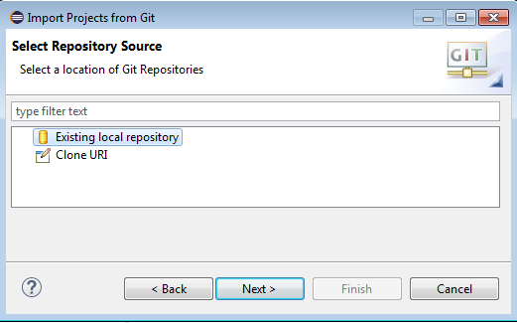

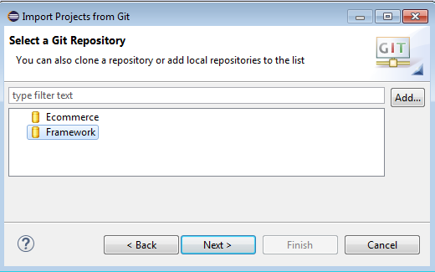

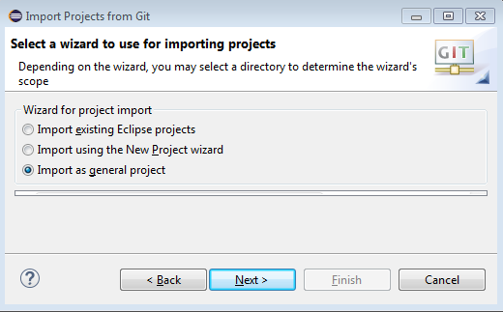

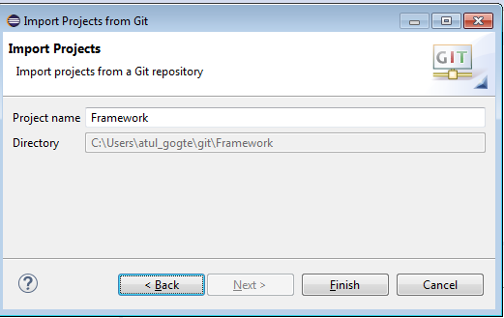

You will see that repository is now imported as project inside Eclipse to be able to make code changes, pull and push the code back and forth with bit bucket repository.

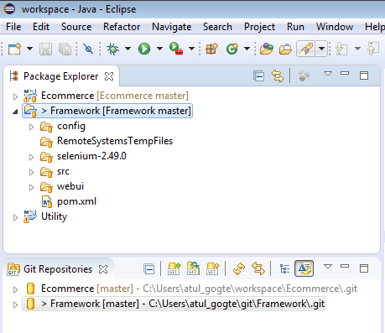

1. The code should then appear in your ‘Project Explorer’ window as a normal project
2. Now make changes to your file as you want
3. Look at ‘Git Staging’ view to see your changed files and Click ‘Commit and Push‘

